**Project Documentation**

**Project C**

*Student Learning Progress/Pair Tracking*

*December 06th - 13th 2018*

Andras Rakoczy - Leader

Luísa Nogueira

Marco Häfner

Mario Weiss

*Team Members*

*Purpose and Scope*

The main purpose of this project is to create a software which will help students and trainers at CodeFactory to track the progress and pair-programming during the Full Stack Web Development course.

We created a software with Login page as index which redirects the user to the following pages, according to their roles:

* Student dashboard with her progress and cards which include the exercises she has for that day according to her course, technology used, GitHub link and her pair(s) partner(s) assigned through an algorithm.
* Administrator dashboard with tables of all users and courses, a calendar, and the options to add new users, courses, exercises and days for the courses.
* Trainer dashboard with option to select one of the courses he is assigned to and where he can check the pair partners previously generated as well as button to generate new pairs for new days.

*Goals and Objectives*

Goals are broad and inspirational, objectives are narrow and measurable. SMART: speciﬁc, measurable, attainable/achievable, realistic and time bound.

Project objectives:

* Create fully responsive dashboards for each user according to their roles.
* Create a student dashboard for each student to access including her name, user name, email, GitHub profile, course name and history.
* Create a pair room where the user can check who is their pair partner for that day, the name of the GitHub repository and the number of exercises for that day. The trainers and students should have access to the pair rooms.
* Create an algorithm which allows the trainer to generate pairs for each day. The data about students who are ready to be paired will come from an external JSON file over API. The pair should be generated through a random function, but it should figure how many times two students worked together to ensure that every student is paired with all other students at least once.
* Create a tracking progress for each student so the trainer can check it. In the progress tracking page trainer should have a view of all pairs and the data about their progress based on students checking which exercise are done for the specific day.
* Create an administrator dashboard where he can manage trainers and students and create new profiles, manage privileges, add new courses and exercises.

*Core technologies*

* Git / GitHub
* HTML5

- SCSS/CSS

* Bootstrap 4
* JavaScript

- jQuery

- PHP

- Ajax

- MySQL

*Software*

*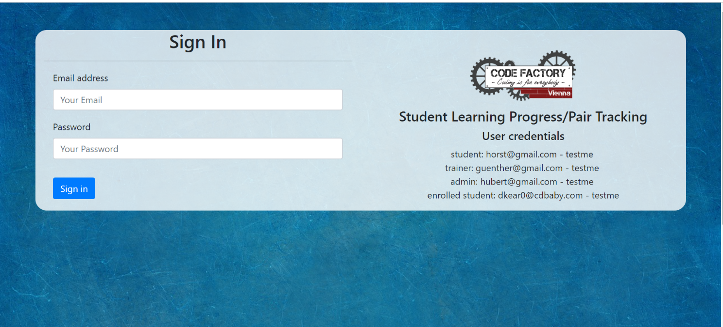Login Page*

*The login page is the index page. If the user tries to link to his page it will redirect him to this page, so he needs to login before accessing the dashboard.*

*Student Dashboard*

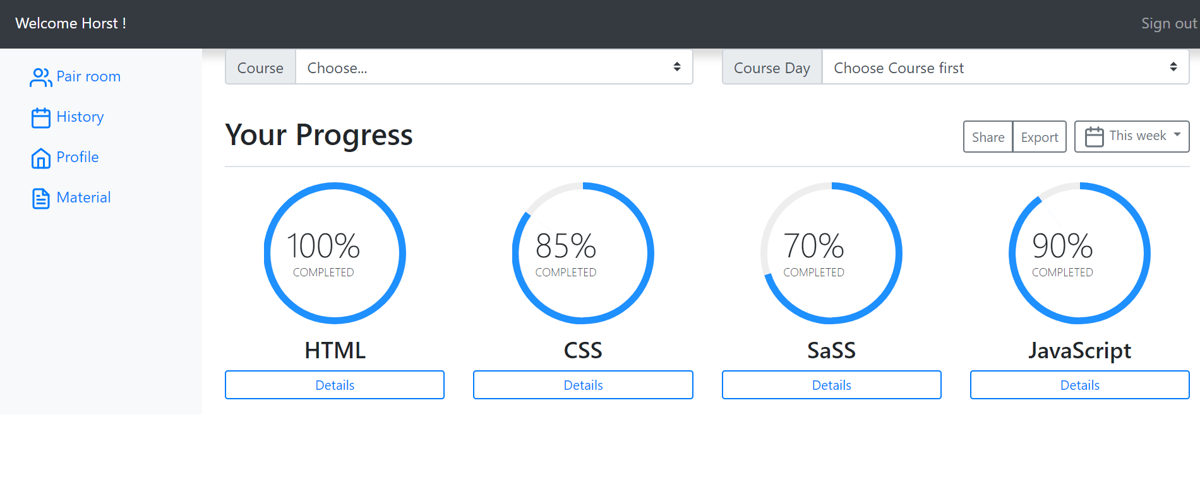

*The student dashboard allows the user to choose a course and then the day. He can check his history of exercises, pair partners by selecting a day he already worked, or check the current day with the information he needs for working – pair partners with the leader in bold, technology that will be used, exercises that can be checked when done, GitHub repository name. He can also check his progress in each technology.*

*Trainer Dashboard*

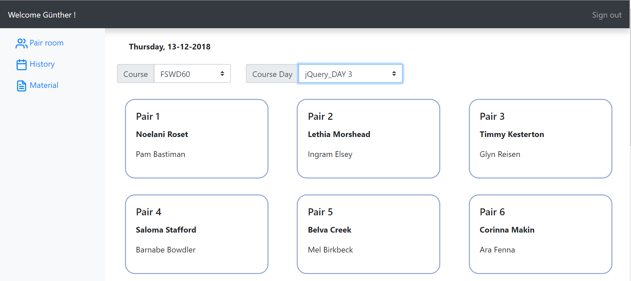

*The trainer can select the courses he was assigned and check the history of pairs for previous days or generate new pairs for new days.*

*Administrator Dashboard*

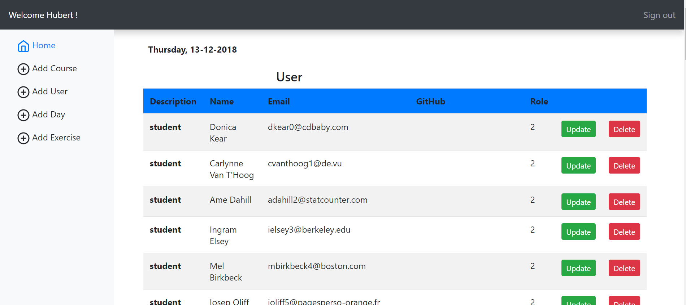

*The administrator has privileges to manage users, add courses, days and exercises. The data inserted will be sent to the database. The tables on his dashboard fetch data from the database regarding users and courses.*